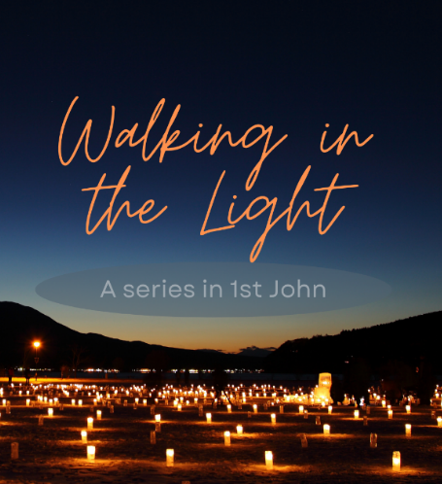

Raleigh St Christian Centre
2023
Bible Studies to accompany our Sunday Teaching

This is the message we have heard from him and declare to you: God is light; in him there is no darkness at all. If we claim to have fellowship with him and yet walk in the darkness, we lie and do not live out the truth. But if we walk in the light, as he is in the light, we have fellowship with one another, and the blood of Jesus, his Son, purifies us from all sin. 1 John 1:5-7
Johns stated goal in 5:13 is:
I write these things to you who believe in the name of the Son of God
so that you may know that you have eternal life.
In a world of grey where questions matter more than answers, John’s letter stands out as a place of certainty for those who are called to walk in the light. John appears to be countering early challenges to the teaching of Jesus. As a direct witness to Christ’s teaching, he is perfectly placed to teach truth and challenge error. In our current age where we have the unprecedented super-power to access information, knowing truth to counter erroneous teaching has never been more important.
The book mixes deep theological truth regarding the person and work of Jesus Christ (e.g. 2:1-2) along with practical outworking’s for those who believe this truth (e.g. 4:19, we love because God first loved us). He regularly uses statements that border on hyperbole that can be challenging (e.g. 3:6 No-one who lives in him keeps on sinning) and must be read in context with other statements (2:1 If anybody does sin…). You cannot read this letter lightly. These techniques force readers to think critically and deeply about what Jesus coming to earth was for. For those who believe this good news, we confront what difference that will look like in our lives to know whether this belief is firm or superficial.
This letter will be a re-assurance to those whose faith is in the person and work of Jesus Christ. For those who don’t yet believe or who are a bit sleepy this book will provide an appropriate challenge.
Thank you for our involvement. Let’s pray for a challenging, encouraging and fruitful series as we dig into God’s word together.

Format
These Bible Studies are designed to accompany the Sunday messages as outlined below.
Each week the format will include:
- The passage to be studied along with repeated prompt questions to use when reading and observing.
  - These prompting questions will be the same each week. I encourage you not to rush this step. Spending time in the text observing will set you up well to discuss the questions together as well as stimulate new ones also.
- Focussed questions to help guide your thoughts.
  - These questions are designed to help you consider the main points of the passage. While you don’t need to stick these questions, use these to help you stay on track of what the passage is aiming at.
- Application questions to take principles away with you.
  - Scripture is given to us so that we would be transformed. We don’t rush to application as we must first understand the authors intent.
Here are some principles from the Movement of the Word training that can help you with your observational study:
- The line. The line refers to what the passage is teaching. It is your goal to find this. We are trying to find enough of what the author is aiming to say without reading into it too much
- Travelling instructions. Before we can bring it to our time and place, we must first consider the audience
- Text over Framework. We all bring to the text our existing frameworks. The text must sit above these but that might take some self-awareness and humility.
- Main Idea and Intended response. God gives us these specific words so that we would be transformed. Our goal is to find the main ideas and intended responses. A good exercise is to summarise the passage in a sentence or two and then share with others in the group.

Proposed schedule for Sunday Teaching:
No. | Date | Passage | Possible Title
1 | 16-Jul | 1 John 1:1-4 | Walking in Fellowship
2 | 23-Jul | 1 John 1:5- 2:2 | Walking in Freedom
3 | 30-Jul | 1 John 2:3-6 | Walking in Obedience
 | 6-Aug | Child Rescue
4 | 13-Aug | 1 John 2:7-11 | Walking in Forgiveness
5 | 20-Aug | 1 John 2:15-17 | Walking with Resolve
6 | 27-Aug | 1 John 2:18-25 | Walking in Truth
7 | 3-Sep | 1 John 2:12-14* | Walking in Encouragement
8 | 10-Sep | 1 John 2:26-29 | Walking with Perseverance
9 | 17-Sep | 1 John 3:1-3 | Walking as Children
10 | 24-Sep | 1 John 3:4-11 | Walking in Purity
 | 1-Oct
11 | 8-Oct | 1 John 3:11-24 | Walking as Generosity
12 | 15-Oct | 1 John 4:1-6 | Walking in Discernment
13 | 22-Oct | 1 John 4:7-17 | Walking in Affection
14 | 29-Oct | 1 John 4:17-21 | Walking without fear
15 | 5-Nov | 1 John 5:1-10 | Walking in Victory
16 | 12-Nov | 1 John 5:11-21 | Walking in Confidence
*Passage not in order to coincide with Fathers Day

